*Ryan Harris s3719229*

*Danny Pham s3719046*

*Jaidyn Jong s3657960*

*Dharal Patel s3719882*

*RAD-dj*

Introduction to Information Technology

**Table of Contents**

**Team Profile 2**

Team Name 2

Personal Information 2

Group Processes 2

Career Plans 3

**Tools**  **3**

**Project Description** **3**

Overview 4

Aims and Goals 5

Plans and Progress 6

Roles 8

Scope and Limits 8

Tools and Technologies 9

Testing 9

Timeframe 9

Risks 11

Group processes and communications 11

**Skills and Jobs** **11**

**Group Reflection** **11**

**Appendix** **14**

Low-Fidelity Mock-ups 15

High-Fidelity Mock-ups 17

References 20

**Team Profile**

**Team Name:** RAD-DJ

**Personal Information:**

**Danny Pham:**

My background is Vietnamese but I was born here in Australia. I graduated from Keysborough Secondary College and is currently doing a course in Information Technology at RMIT. My hobbies are playing video games, playing badminton if i have the chance, watching TV shows like The Flash and Agents of Shield. I also like to take photos and building computers. Fortnite squad up. My IT Interest is in Networks and Cloud Computing.

My experiences in IT has been doing Computing in Year 11 and doing work experiences in Year 10 at a computer repair shop.

**Jaidyn Jong:**

I was born and raised in Melbourne, Australia, with my background being half maltese and timorese. I completed my year 12 studies at Copperfield College, where I graduated in 2016. Currently I am studying a bachelor’s degree in business, majoring in economics and finance and am in my second year of the course. In my downtime, I enjoy spending time playing sports and catching up with friends, working on cars, as well as playing video games and watching YouTube videos. In relation to IT, I am interested in programming, analysing databases, networking and cloud computing, where I have been taught the basics of these skills in my year 11 and 12 studies where I took IT related subjects.

**Ryan Harris:**

My background is that i’m half irish and half Australian, but i was born in Sydney, Australia, and have lived in melbourne for as long as i can remember... I graduated from Brighton secondary college in 2017. I am currently in my first semester of studying IT at RMIT. I’d say that my hobbies would be playing video games (both PC and ps4) as well as watching tv, and by tv i mean netflix, stan and youtube. IT wise, i’d say i’m pretty interested in programming and creating programs using this, and i have had very little experience with IT in my junior years.

**Dharal Patel:**

I was born in India then migrated to Australia at the age of 14 where I completed my VCE in Maribyrnong college 2017. Currently, I am studying Bachelor of Information Technology at RMIT. My hobbies include playing Cricket and video games and I spent most of my time watching Youtube and Netflix. My career ambition is to become the very best programmer thus I code and program in my spare time. This passion of mine started back in high school when I was taught basic coding in my IT classes.

**Group processes:**

Our group worked very well in Assignment 2, as the assignment was done on time and to a high standard, so not much will be changed in this assignment, except for adding in a more cohesive timeline for the report in order to complete Assignment 3 on time, as it is more complex than the previous one. We also want to make sure that in assignment 3 everyone commits to Github and also pulls request as we didn’t had any pull any requests in assignment 2. And we also want to improve our communication as we lacked a bit in communication in assignment 2.

**Career plan:**

The ideal jobs for each group member are relatively similar in terms of being IT related, with the exception of one of the jobs being the Economic Regulator. Some of the common elements and general skill sets that each of the ideal jobs require are communication and problem solving skills which are the main elements which sets the jobs alike. As for what differentiates each position from one another, three out of the four IT related jobs (Support Analyst, Software Engineer and Systems Admin) obviously require a degree of knowledge in IT specific areas such as JavaScript and SQL, whereas non-IT pathways like the Economic Regulator would not demand skills in these areas. In terms of what sets the IT related jobs apart, a support analyst should also have troubleshooting skills as a key skill in addition to the basic IT requirements, similarly to the software developer. A system admin on the other hand must also be detail oriented and have a structured way of thinking much like the software developer. After having received feedback from our previous assignments, we are all likely to still pursue our ideal jobs, knowing that at present, they are likely to still be in great demand.

**Tools:**

With Assignment 3, we had a group website where all of our profile is. Then we have a trello board where we implemented due dates and assigned roles. Then we created the prototype using inVisionapp. And created presentation about our IT Project. And had a Github repository. The commit trail on github shows that all group members have committed. We had google docs to write our report where everyone can write on the report at the same time. The google doc shows that all members equally contributed to the group. The links to all of these are as follows:

**Team Website:**<https://dharalpatel.github.io/IT-Project/>

**Team Github:** <https://github.com/DharalPatel/IT-Project>

**Prototype Link:** [https://invis.io/WJKL5J0VYBC](https://l.messenger.com/l.php?u=https%3A%2F%2Finvis.io%2FWJKL5J0VYBC&h=ATPnHJfLQmVcic-2X3R72QUJR1S-UBlLEuSbWKFy3sT4tRAELkQc3WSLM3zv8UqrqlJDT-0W_6k_J1PxsoJrpgqT3E1ys476YCT8YmqYzyozpERfiSD-gv8SnHI)

**Presentation Link:** <https://tinyurl.com/y9knxus5>

**Trello Board Link:** <https://trello.com/b/M0scECsx>

**Project Description**

An app for your dog(s) that allows you to:

* Track walk time/ length
* Remind you of feeding times
* Give recommended information for dog breed
* Information about the dog will be shared across all devices

The app will consist of:

* Main screen:
  + Will have a sign in page
  + This will be where you can "add" your dog to the device, you register the dogs age, breed, name and gender
  + Will also be a feature to "share" a dog across multiple devices
    - Useful for families or dogs with multiple people looking after it such as a dog walker
* Walking screen:
  + Will first have you select your dog, or multiple dogs and start the walk
  + Before starting the walk, there will be information about the dogs recommended walk length for their expected size and breed. For example "Muttons is a German Shepard who is 4 years old and so needs  about 30 minutes. The app can also take into account the weather in this info (optional)
  + Will be a button to begin walk, which activates a timer and a pedometer.
  + After the walk, there will be a button to "end the session" this will display a map of where you walked, as well as the overall time and distance covered
* Feeding screen:
  + The times for feeding a dog will differ between each owner individually, so the owners will be prompted to select their dog and enter their preferred eating times.
  + The app will also give recommended serving sizes depending on the dog breed
  + After entering the preferred eating times, the app will then set an alarm 10 minutes before this scheduled time to remind the owner to feed the dog. Can be turned off or changed to a push notification
  + After feeding the dog, the owner hits a button that checks off the dog and signifies it as " fed", so now every member of the family can see that the dog has been fed

**Topic**

Our Assignment 3’s group IT project will be an application in conjunction with a device that has the functionality to monitor your dog’s main attributes. The main components that the device will encompass is a GPS tracker, a step counter and a thermometer that attaches to the collar of the dog, the device will have the ability to communicate with the app on your mobile device.

The application will allow the user to monitor the amount of physical activity the dog has completed, notify the user when the dog needs to be walked based off of the GPS tracker, allow the user to check off if the dog has been fed or not, and the ability to observe the ambient temperature around the dog to see if the dog is at any risk of overheating.

**Motivation**

The motivation for this project was based off of Ryan’s personal needs, as well as the needs of many dog owners, as it can sometimes be hard to keep track of your dogs health, especially when there are multiple members of the household. The project is important as it can help owners more closely monitor their dogs health and ensure their well-being by taking action when necessary. To a future employer, working on this project would show our group members ability to create and plan an app/ IT project, as well as show them that the group member are able to work on a project that they necessarily don’t have stakes in, or aren’t as interested in as Ryan, which is an important quality for potential employers to look out for.

**Landscape**

Here are some similar apps:

* Dog walk by Tractive (highest “competitor”)
* Map My Dog Walk
* Dog Walk Tracker & reminder by Halcien labs
* Dog Log by apps for good UK
* Hungry dog tracker & reminder by Halcien labs
* Pet diary by Behrang Javaherian

However, most of these apps are solely focused on dog walking or dog feeding, and not both at the same time, unlike our proposed app. The most polished and highest rated app was the Dog walk by tractive, it had a sleek and stylish design with many functions similar to what we would like to implement. A main point of difference our app would have to other one’s available, would be the tracking of walks and eating schedules in the same easy to use app, as well as the linking of multiple owners/ devices to one dog or multiple dogs, which would be essential for a family trying to use our app. It can be expected that this app can be created to be able to stand out from the rest.

**Detailed Description**

**Aims**

Our aim is to provide an application which will enable you to track your dog’s food and walk schedule. We aim to provide our users with an application which will allow the user to keep track of their dog’s health and wellbeing, whilst taking the complexity out of an everyday pet owner’s life in tracking these daily tasks. The app will be able to inform them about this information and will also remind them to feed their pet if they haven’t been fed. The app will allow to track dog’s walk by using GPS which will be fitted in the dogs collar. The GPS will be connected to their mobile devices and will allow them to start their dog’s walk at a particular time or location. Alongside this feature, it will also display the recommended duration of the walk based on the pet’s characteristics such as its breed, weight and age. For example, a German Shepherd may require a longer exercise period than a chihuahua.

**Goals**

One of the goals will be to ‘design the application’. The GPS tracker will be connected to the application where all the actions will be performed by the user. So the first task towards creating an application will be to design how it will look like by creating mock-ups. This is where all the designing of the application will be done and it should be designed while keeping the users in mind. This goal will help towards achieving in our aim to make an application that will allow to keep track of dog’s care. Designing the application be will the first task in creating the application.

Another goal would be to create prototype of the application. For this project, the farest we are going to go is creating a prototype in invision where the prototype will we tested. Prototypes will be created using Proto.io which is an online tool that can be used to create prototypes. Prototypes will be created using the high-fidelity mockups. Prototypes will be used to create the final product after getting user testing. Prototypes will be used to achieve our aim.

Getting user testing will be another goal. After creating prototype, getting user feedback is important as they are the ones who will be using the product. If the users are happy with the product then only they will recommend the the product to others. So getting user testing will help us to identify any bottlenecks in the app which will fixed later to make the app as productive as we can. After alterations, the application will be created which will achieve our aim to provide an app that help users to take care of their dog by using our app.

Another goal will be to create the product. The application will be created by a programmer who will program the app by using our designs and prototype. After creating the application, it will be again tested by some users to see how the final product will look like and to identify if there are anymore problems. After that the app will be made public and used by users. This will help to achieve the the aim as the users will be using the app.

The final goal will be to advertise the product. After the app being made public, advertisements will be created to let the public know that our product exists to fulfill their needs. The product will be advertise on Google Play, Youtube and many more social media platforms. By advertising, the users will be aware of the product and will recommend the product to others thus increasing our users. This will help achieve our aim as users will be using the our product to take care of their dog.

**Plans and progress**

Our project idea being the My Dog App, will be designed and partially implemented to assist dog owner’s with keeping track of their dog’s health and state of wellbeing. This idea came about from Ryan, in order to assist not only him, but several thousands of other pet owner’s in helping them achieve this everyday task. More specifically as to what our project will accomplish, it will enable the end user to be able to keep track of the walking and feeding times and recommendations for their specified dog, based on their breed, weight and age. The app will also specify the length and duration of the walk recommended for the dog based on these characteristics.

Our team name that we decided to use was RAD-DJ. This was relevant to us as it is the initials of everyone in our group. A member that was in our group for the previous assignment only joined for one tutorial however we still kept his initial in our team name to signify all the members that have joined our group. Our group idea was then decided when everyone brought forward their idea, we resonated with Ryan’s idea the most. Later, roles were assigned to each member and the idea of having due dates for parts of the project were then decided on trello. This happened in the first week of planning, May 8th.

For the project planning; the topic, motivation, landscape, roles, aims and goals were completed the week after on May the 15th.

We spent the majority of our time researching other competing applications on the app store and Google Play store and found a discrepancy between other ideas and our idea. Other applications only had the feeding idea and not the walking feature vice versa, so we decided as a group to incorporate both of the features together. In doing so, we presumed that it would put us ahead of the competition for similar applications related to human-pet interaction, thus translating into greater potential for our application to succeed on the Google Play store (as our application is only available on Android OS).

In terms of developing any features or outcomes for this project and how far it has progressed, we currently have an idea set out for what this application will feature in each of its screen:

* The home screen will display a grid layout page in which it will prompt the user to ‘Add a dog’ entering in the relevant details such as their dog’s breed, weight, name and gender. After setting up the profiles, the dog profiles will be displayed in a grid in the main screen. This screen will allow the user to access other features of the application such as the feeding screen, walking screen and the settings.
* The feeding screen will prompt the user of a first time setup tutorial for creating a feeding profile, this will be shown if it is the first time using the feature. However, adding more dogs feeding profiles can be added in the feeding screen without the tutorial. Users will then select their dog, then how many times they can eat a day and a time to notify them. Recommended serving sizes will be provided to the user as an indication of a rough incentive.
* The walking screen will display a list of the user’s dogs, prompting the user to choose a dog to walk. The following screen will portray a recommended walking time and distances depending on the dog’s DogFile. The next screen will show a map showing your location. The distance will be calculated through the location difference from your mobile device relating point A to point B. After finishing the walk, statistics will be shown such as weekly goals and calories burnt.

These main features have been brought to life using proto.io and inVisionapp online applications. We plan to add more main features to the application through feedback from existing users who will use our application, in hope that they will come across any additional extensions that may help the application, from benefitting to suit more individual needs. In general, we would not consider any feedback which we believe to be irrelevant, or which may only hinder our application negatively, for example if a user recommended to add a feature to try and teach dogs to understand English, or any other language. Such a recommendation would be out of our scope for what we are trying to achieve, however may be a possibility for another future application.

At the start, we were planning on creating a device using the Arduino kit which measured the temperature, location and heart rate of the dog. However with our groups inadequate knowledge of Arduino programming and identification of devices to use, we decided to go on separate paths from using Arduino. It would have taken a long time for parts to arrive and even longer time to program the devices. Alongside linking the device with the application. This decision was decided by the group as we were running out of time.

The stage of the project that we are currently at is hiring an application developer to bring our prototype to reality. We have completed our high fidelity prototypes which gives us the incentive to create the application coded by an application developer. This would obviously be done by a professional application developer, as with the knowledge that our group members possess within this field would not be sufficient enough to be able to satisfy the quality and characteristics that our application should bring.

In terms of what we have planned for the future for our application, we may want to try targeting our application to meet the needs of even more people, not only through dogs, but also other pets, such as fish or cats. Similar characteristics of the app will remain unchanged when being used to track other pet’s, such as the ‘walk’ and ‘feed’ functions. We may also consider ‘revamping’ our application to freshen up the dated look and visual aesthetics of our app if we feel that it requires a new appearance. The adoption of major version updates like these will however will need to be designed and approved by mobile application designers, such that it doesn’t hinder the functionality of our application and how it is ‘supposed’ to perform prior to major changes like such.

Furthermore, as shown in our **testing** subsection, weeks 15 to 16 will be primarily used to promote our application via mobile advertisements potentially, in hope to gain a user base who will potentially continuously use our app to assist them in their lives. Our ads will consist of short video clips displaying a user who will be using the app on their phone and using the ‘walk’ feature to show how it can assist them. Although it is not our main objective to acquire money through our advertisements, however any additional revenue made through our ads shall be put to use, to improve the existing app and to fund for our expenses such as our designers and developers.

**Roles**

The specific roles are as follows:

**User Interface Designer:** Ryan, Danny

**Tester:**  Dharal, Jaidyn

The user interface designer is responsible for designing the program by keeping users in mind and develop products that meets users’ needs. In our project, Ryan and Danny designed the application. They created mock-ups: low-fidelity and high- fidelity, and created prototype.

The tester is responsible for testing the design the designers made. The tester checks if the design meets users’ needs and provides feedback about the program. In our case, Jaidyn and Dharal tested the design and provided feedback on the designs made by the designers.

There were general roles which changed from week to week. These are described in the table below along with timeframe.

**Scope and limits**

The scope for our project is the prototype which will include all the features on the app. The prototype will be able to show the features of the app, but it won’t include the GPS belt which will be on the dog’s collar. The prototype will be able to show how to add a dog, but it won’t show the list of all dogs. It will also be able to show the walk and feed feature, but these are hardcoded in the prototype which means that the user won’t be able to alter it. Everything is hardcoded, but the prototype shows how they will function which is closest to the final product. The prototype will not be able to show the time it takes to load each function.

**Tools and technologies**

* Arduino UNO
* Arduino Software
* Wires
* LM35 Temperature Sensor
* Proto.io
* inVisionapp

All members in the group had experience with Proto.io and inVisionapp as we had an assignment in User Cantered Design course which required us to make a prototype.

**Testing**

We want to have user testing done after the prototype is created. The users will use the prototype to test. Testing after prototype is a good idea as it is easy to change during this stage of development. We will find the testers from our group members families as the motivation for this project was from the group members who wanted a program to take care of their dog. For the prototype we are looking to have about 10 testers will be easy to get from group members’ families. If the users find any problems, then we will be able to change it easily. Testers who owns a dog will be taken as they will be well known of the troubles to take care of dog.

**Time frame**

Below is the time frame for 16 weeks. We planned and implemented due date on trello. The link to the trello board: <https://trello.com/b/M0scECsx>

|  |  |  |  |  |
| --- | --- | --- | --- | --- |
|  | **Ryan** | **Danny** | **Dharal** | **Jaidyn** |
| **Week 1** | Deciding on Project | Deciding on Project | Deciding on Project | Deciding on Project |
| **Week 2** | Team Profile,  Assign Roles,  Implementing due dates | Team Profile,  Assign Roles,  Implementing due dates | Team Profile,  Assign Roles,  Implementing due dates | Team Profile,  Assign Roles,  Implementing due dates |
| **Week 3** | Features | Features | Features | Features |
| **Week 4** | Low-fidelity mock-ups | Low-fidelity mock-ups | Report,  Testing low-fidelity mock-ups,  Presentation | Report,  Testing low-fidelity mock-ups,  Presentation |
| **Week 5** | High-fidelity mock-ups,  Presentation,  Prototype | High-fidelity mock-ups,  Presentation,  Prototype | Testing high-fidelity mock-ups, Presentation,  Report | Testing high-fidelity mock-ups, Presentation, Report |
| **Week 6** | Prototype,  Report | Prototype,  Report | Testing,  Report | Testing,  Report |
| **Week 7 (est)** | User Testing | User Testing | User Testing | User Testing |
| **Week 8 (est)** | Changes to Prototype | Changes to Prototype | Hiring Programmers | Hiring Programmers |
| **Week 9 (est)** | Programmer Interview,  Explaining Project | Programmer Interview,  Explaining Project | Programmer Interview,  Explaining Project | Programmer Interview,  Explaining Project |
| **Week 10 (est)** | Programming App | Programming App | Programming App | Programming App |
| **Week 11 (est)** | Programming App | Programming App | Programming App | Programming App |
| **Week 12 (est)** | User Testing | User Testing | User Testing | User Testing |
| **Week 13 (est)** | Fixing Issues | Fixing Issues | Fixing Issues | Fixing Issues |
| **Week 14 (est)** | Publishing App | Publishing App | Publishing App | Publishing App |
| **Week 15 (est)** | Promoting App | Promoting App | Promoting App | Promoting App |
| **Week 16 (est)** | Promoting App | Promoting App | Promoting App | Promoting App |

**Risks**

Some risks that may occur in our project is the incapability of being able to demonstrate the features given, as we have do not have the required experience with Arduinos and mobile application development. However, when implementing the application, it would be likely that professionals within the specific fields of development would be employed in order to assist us in developing our concept, therefore limited the possibility of risks occurring.

**Group processes and communications**

Our group communication will be conducted both in class and out of class. For out of class, we will use the social media platform Facebook, where we have created a messenger group for which we discuss our plans for the assignment. We expect communication to take place at least once to twice a week. As all of our group members are frequently active on this platform, we should have no problems when it comes to no communication from our group members. In order to avoid any project failures, our Trello page will help each member keep track of each individual task which will eventually need to be accomplished, as well as displaying the due dates for each of these tasks.

**Skills and Jobs**

As previously mentioned in the ‘risks’ subsection, we would find that future potential employees with plenty of experience with Arduinos and mobile application development would definitely be a requirement for a position to help take our project to the next level, when it comes to technical expertise. These applicants should also have done previous work similar to that of this project in the past, so that they are exposed to what they are required to do. Another requirement for potential applicants would be someone who has very strong innovative skills, who can employ new ideas and concepts into a variety of different situations based on current needs of consumers. This is to help our project stay up to date and to continuously be on the edge of innovation above our competitors. Someone who possesses great managerial and leadership skills would also be of much benefit for our project so that they may act as our co-leader, as well any other potential applicants whose knowledge and level of expertise in other fields such as application designing would be of value for our project.

**Group Reflection**

With this assignment, everything went well as everybody did their part and especially with the presentation. The presentation was really good, and it did finish in time with all the points covered. Everyone was present and was on time which was good as we saw that some groups had one or more members missing or the group wasn’t there. But with ours it was good. Also, with the project idea, it was also very good as it was motivated by all group members. It was developed from assignment 2 and was continued from there on. Again, with this assignment one thing that could be improved is communication. It was better from assignment 2 but it could have been improved more. We had class time and after that it was only messenger where we communicated. But it was better than assignment 2 as everyone responded quickly with the discussion out of class. Communication could have been improved by meeting outside of class, but it can also be understood that we had exams, and everyone was preparing for other exams. One thing that was surprising was the fact that we got through the presentation in time as in our session many groups ran out of time. Also, other thing that was surprising was that everyone was available during the presentation. We didn’t have to change swap the times with someone.

The GitHub commit trail implies that all group members committed on GitHub. There wasn’t much to commit except for updating the report. We wrote the report on the google documents where everyone contributed equally. We used trello to assign roles and implemented due dates. Everyone followed that due dates and their roles and finished their tasks in time which helped finishing the report in time. The ‘Done’ list on the trello board shows who completed which part and in what time. Everything was completed in time considering the fact that everyone had exams to prepare for. One thing the group learned as a whole that the number of things that needs to be considered when creating a IT Project. Things such as due dates needs to be considered to see if all tasks are completed in time. Also see if everyone did finish their assigned work in time so that there are no delays in completing the project. So, creating an IT Project involves a lot of things to be taken care of.

**Individual Reflection**

**Ryan:**

In this project, every member pulled their own weight and deadlines were met and so the work could be completed on time and to a satisfactory level, also, the group was able to get along well without any real interruptions. However, something that could have been improved was perhaps more cooperative work and less compartmentalization as well as more face to face meetings. I found it surprising how it is possible to plan out an IT project to completion at our current level and to have an idea which could become an actual product. I learned from this group work that splitting the work into smaller chunks for every member to complete allowed it to be done faster and more efficiently. This assignment did not require much use of GitHub, due to the lack of coding and by using google docs to work on the report collaboratively, which would cause it to be less accurate as a log of our activity as a group. However, I do believe that every member is capable of using it efficiently.

**Jaidyn:**

In general, our assignment 3 project went very well considering every group member performed their assigned task given to them by the deadlines set. The quality of the work put in by every member was also of a high standard, which was of relevance to the topics which were meant to be discussed. However, improvement could have still been made in several areas such as outside of tutorial meetings and the amount of communication that could have taken place on our messenger group chat, as discussion mainly took place when deadlines were very close. Nevertheless, all requirements were achieved by each member of the group. As per how we managed the completion of assignment 3, the fact that we were able to divide most of the work up, as well as the use of Trello made the assignment feel less complicated. One of the biggest things I have learnt from doing this group assignment is that communication must occur in order to actually get objectives completed, as communication also motivates each other member to also do their work.

**Danny:**

In the end, we managed to complete the assignment. This assignment gave us insight into the process of starting a project and explored all the steps to planning a project. Everyone in the group successfully completed their parts relating to the assignment. One thing that i found surprising was that we managed to complete our presentation before the five minute limit even though we had a lot of content to talk about. One thing i learnt about groups is that communication is very vital when working as a group. For reference working alone, you don’t need to talk however working as a group, communication is much needed. For our GitHub logs, i managed to commit some files. However we did most of the commiting on google docs.

**Dharal:**

Overall everything went well with this assignment. We got to experience how an IT Project is planned and worked on. Making an IT Project involves a log as process and a lot of things needs to be taken care of including planning, designs, group work. With our group everything was good as all members were active and responded quickly when asked. One thing that could be improved is meeting outside of class. Every Week we only have class where we can discuss but to improve more meeting outside of class time would be of an great advantage. We have a group set up on Facebook messenger but it's not enough. Discussing in a group would be great. But it can be also seen that everyone had exams to prepare for but overall our group had communication on messenger which made it possible to work on the project easy. We completed everything on time and everyone what they were asked for. One thing that was surprising was that we finished the presentation in time and everyone showed up at the presentation and everyone was available for the presentation which is surprising as we saw some groups which had members missing. As said before, meeting outside of class would be a learnable thing as it helps to discuss more easily rather than to type on messenger.

**Appendix**

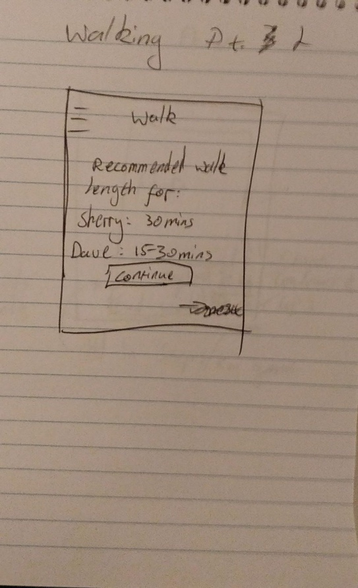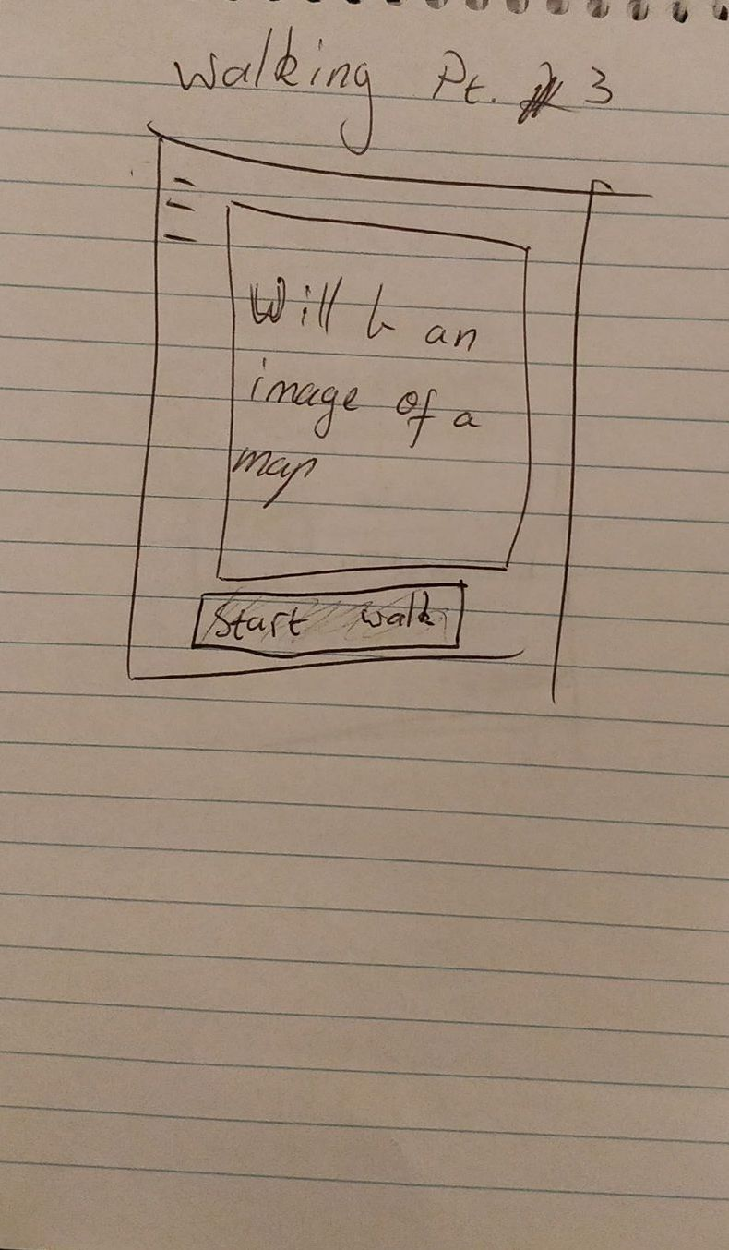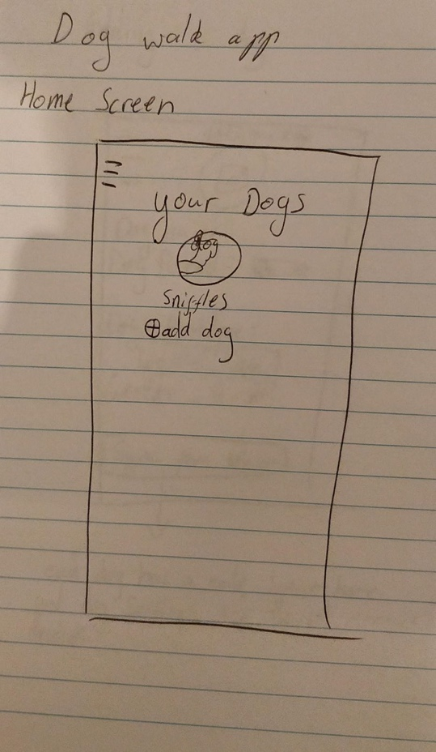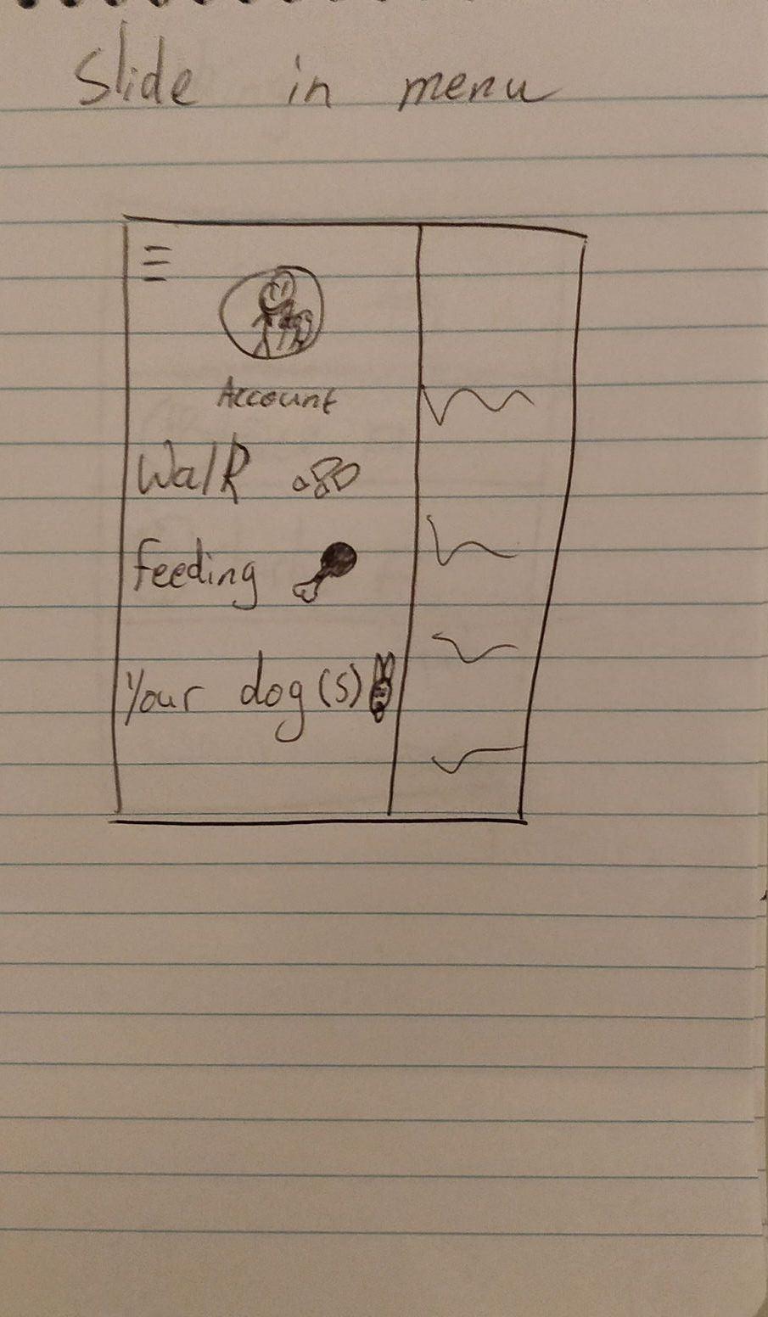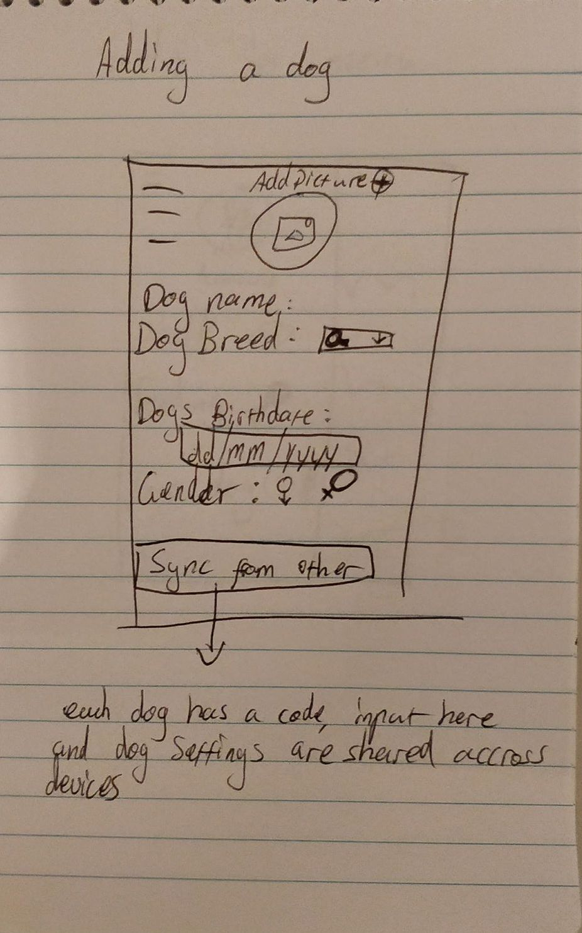**Low-Fidelity Mock-ups**

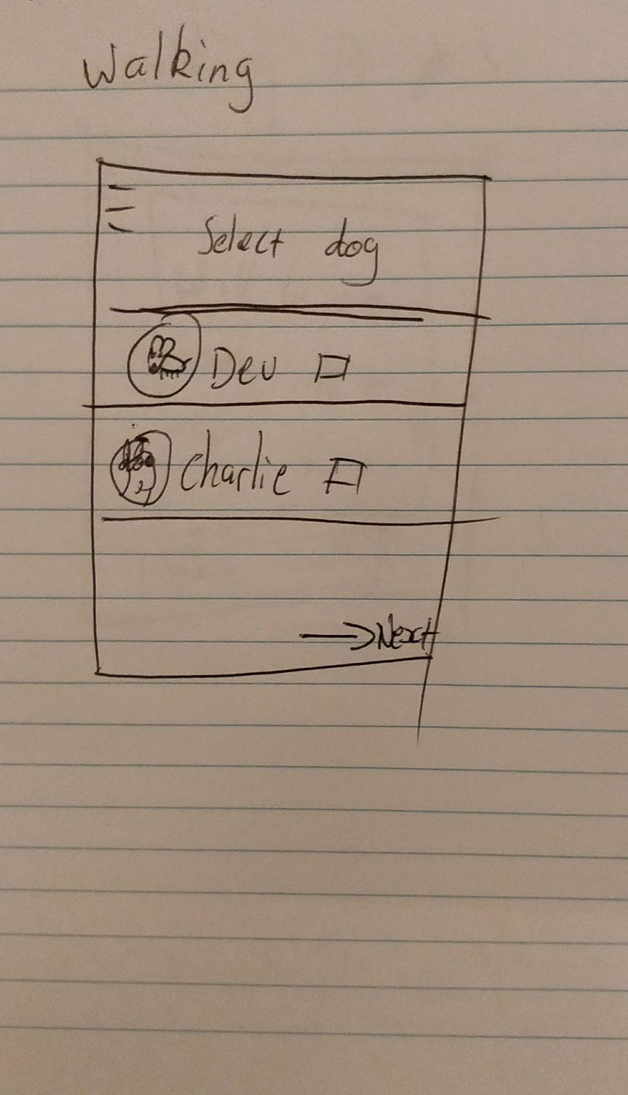

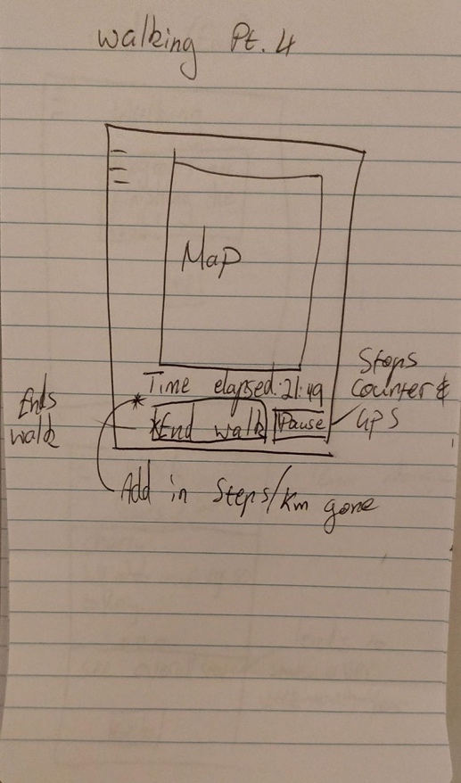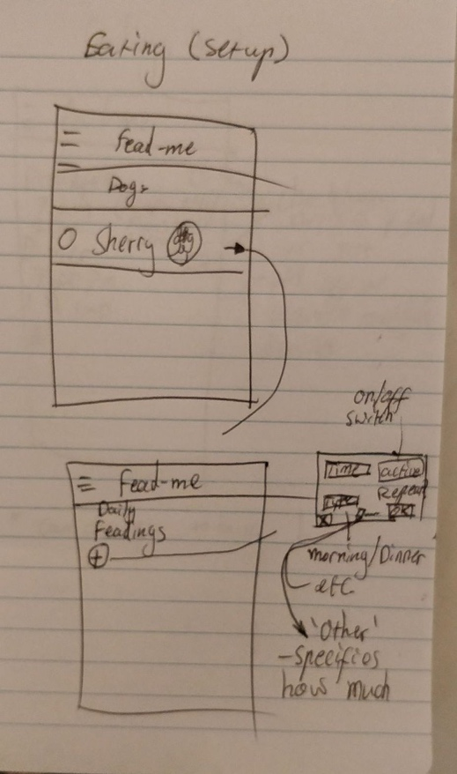

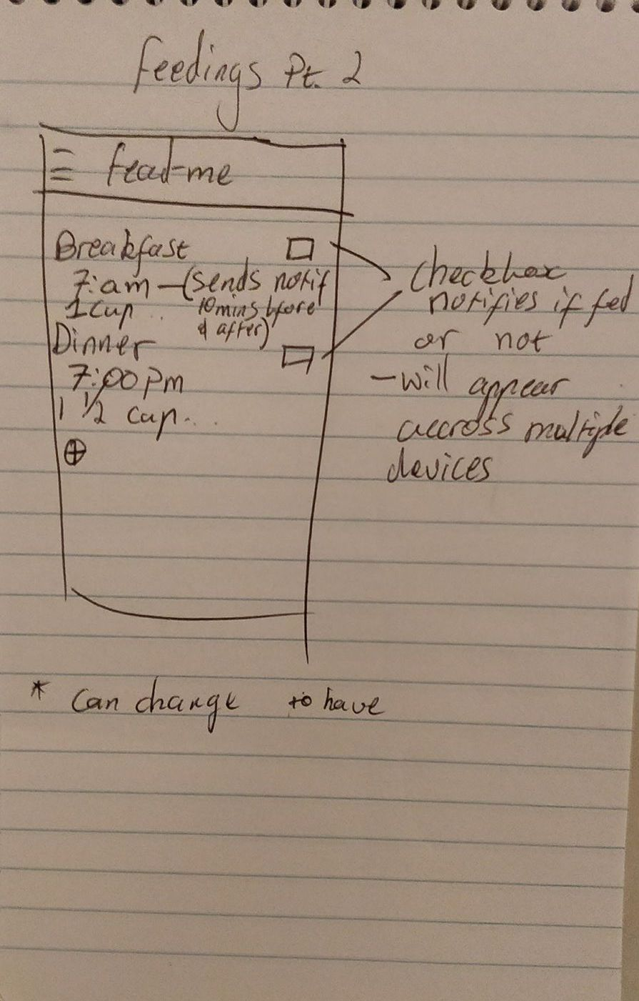

**High-Fidelity Mock-ups**

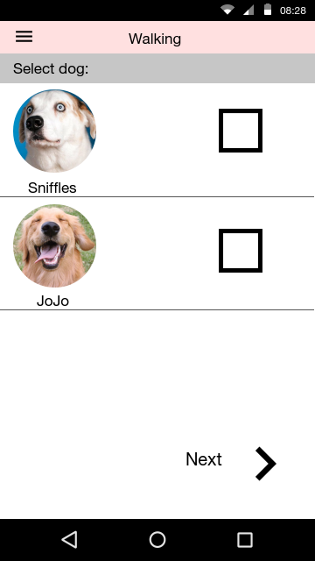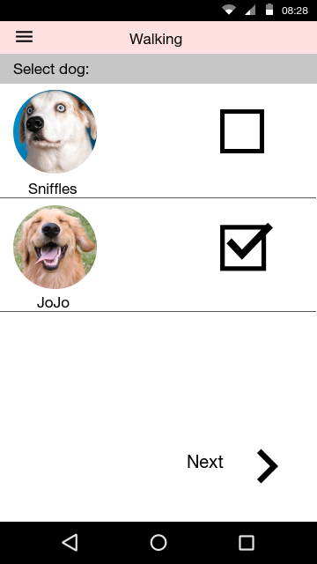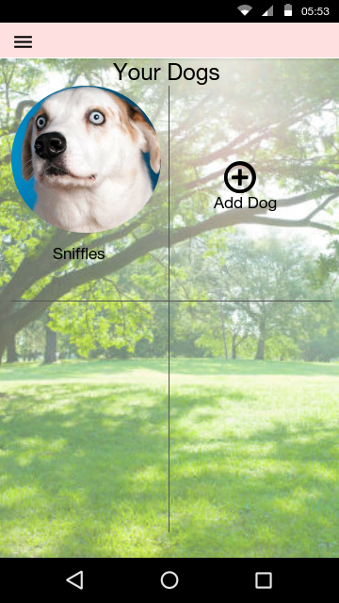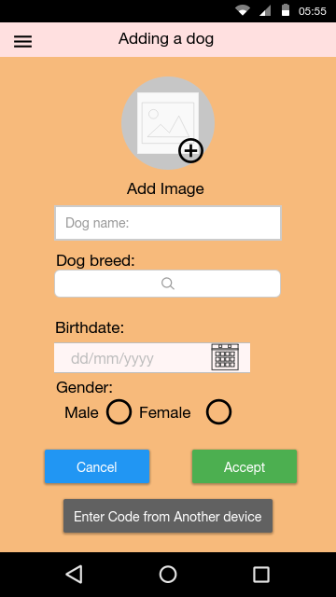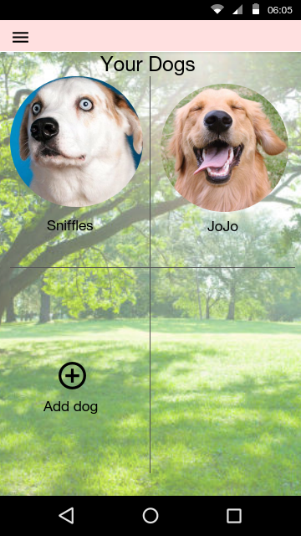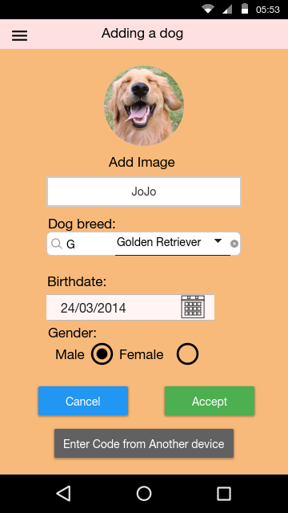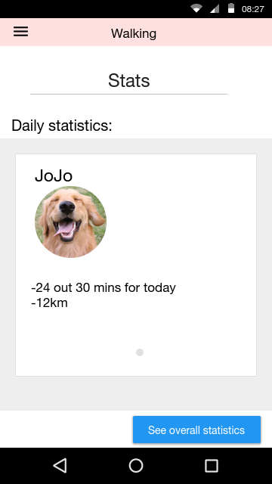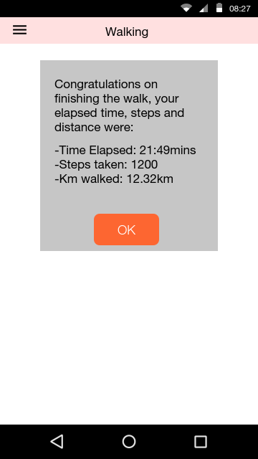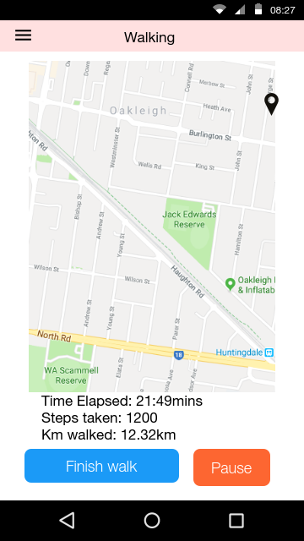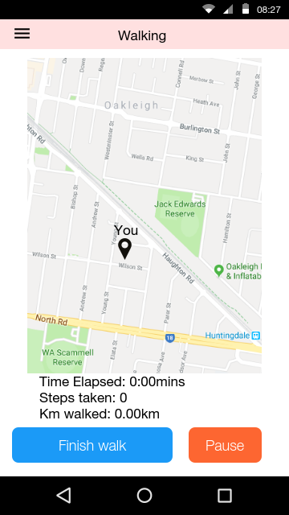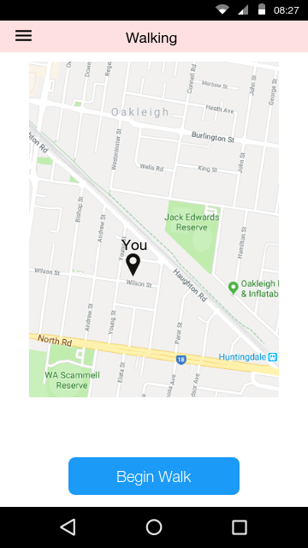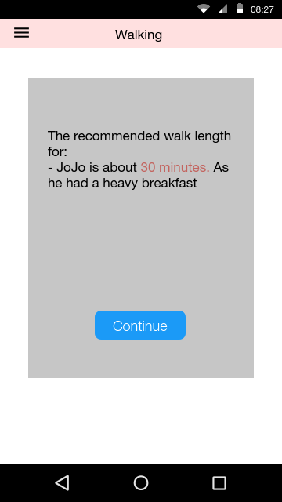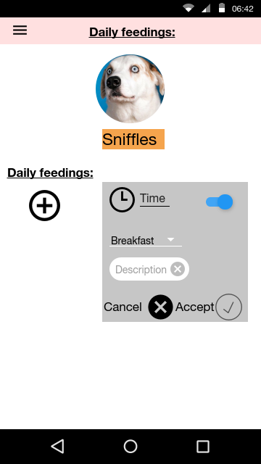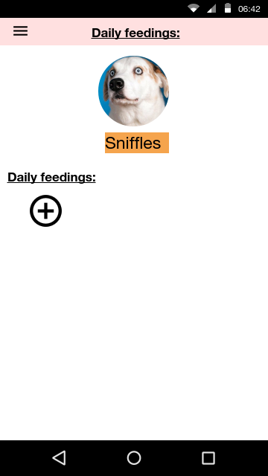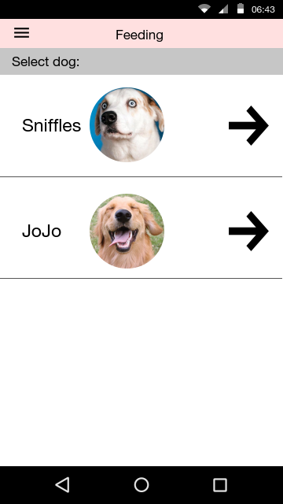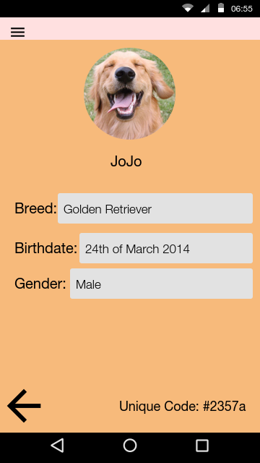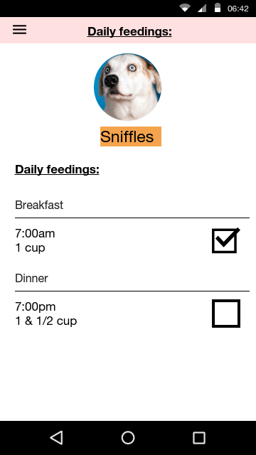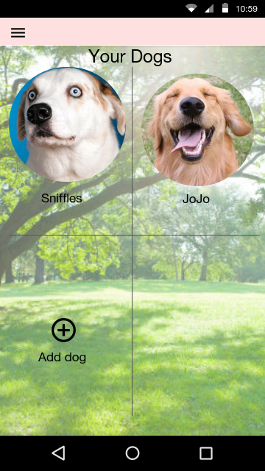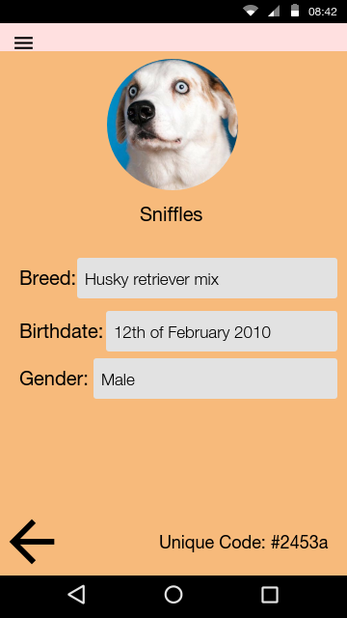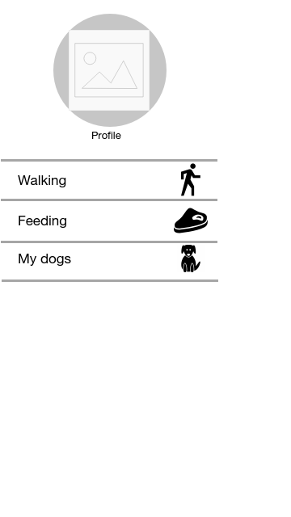

**References**

1. BarkPost, The 15 Best Apps for Dog Lovers and Pup Parents, Retrieved from <https://barkpost.com/life/15-dog-lover-apps/> [Accessed 8 May 2018]
2. Grace Smith, 3/12/2013, *10 Excellent Platforms for Building Mobile Apps,*Mashable Australia, Accessed may 8th 2018,<https://mashable.com/2013/12/03/build-mobile-apps/#Gw0QOXOCuPqc>

**THE END**